1.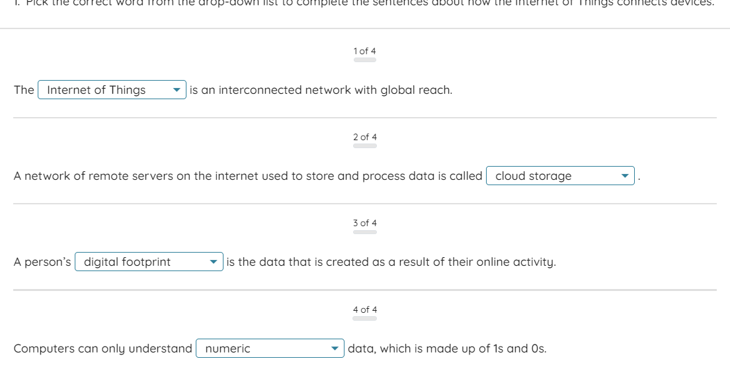

2.
Read these statements about the Internet of Things. Which are true, and which are false?
1 of 7
Not attempted
The Internet of Things is a network of smart devices connected to the internet.
True
False
2 of 7
Not attempted
A smart watch can transmit data to the Internet of Things.
True
False
3 of 7
Not attempted
Smart phones do not transmit personal data to the Internet of Things.
True
False
4 of 7
Not attempted
IoT devices do not need a power source.
5 of 7
Not attempted
IoT devices use sensors to collect data from the physical environment.
6 of 7
Not attempted
Latency describes the speed at which data is downloaded from the internet.
7 of 7
Not attempted
Bluetooth is a short-range wireless technology.
